Analysis

# Functional requirements

1. The system must be able to track the current date
2. The system must be able to extrapolate current month and/or week from current date
3. The system must store the employees name, employee code (1), training info (2) and test preferences (3), to be called Credentials (4)
4. The system must be able to differentiate between employee and team leader (5), as only the team leader can make changes
5. Users must be able to search for specific schedules or type of analysis
6. The search function must be able to search using keywords, such as names, codes, analysis type and date
7. Team leaders must be able to mark days of a specific employee as vacation days
8. The system must be able to differentiate the vacation marks (see requirement 8) into 2 categories: Accepted vacations, and vacations pending acceptation
9. The team leader must be able to comment on specific dates of an employee
10. The system must be able to store a worksheet which records how many employees are needed, for any specific test in a specific week
11. Team leaders must be able to request for an employee on another team to be assigned on a task on another team
12. The system must be able to accept a request for an employee to do an assignment at another team, from an external team leader and record the employee’s temporary assignment to the other team
13. The system must be able to prevent illegal inputs, like a character in an age
14. The team leader must be able to add, change or delete a work-schedule on a specific date of a specific employee
15. The team leader must be able to add, hide or remove employees from the registry
16. The team leader must be able to put multiple analyses on a single day of a specific employee
17. The schedule must be available without installing an application
18. The system must keep track of employees tasked with the different assignments
19. The system should alert the team leader if the number of employees on a task is less than the minimum required (see requirement 10)

# Non-functional requirements

1. The system must be developed in Java
2. Scheduled vacations (see functional Req. 8) must color accepted vacation red and vacations pending acceptation yellow
3. The stored training info (2) should be colored:
   * Purple for approved employee
   * Red for employee needing retraining
   * Yellow for employee under training
4. The search function must return results within 2 second 95% of the time

# Use case diagram

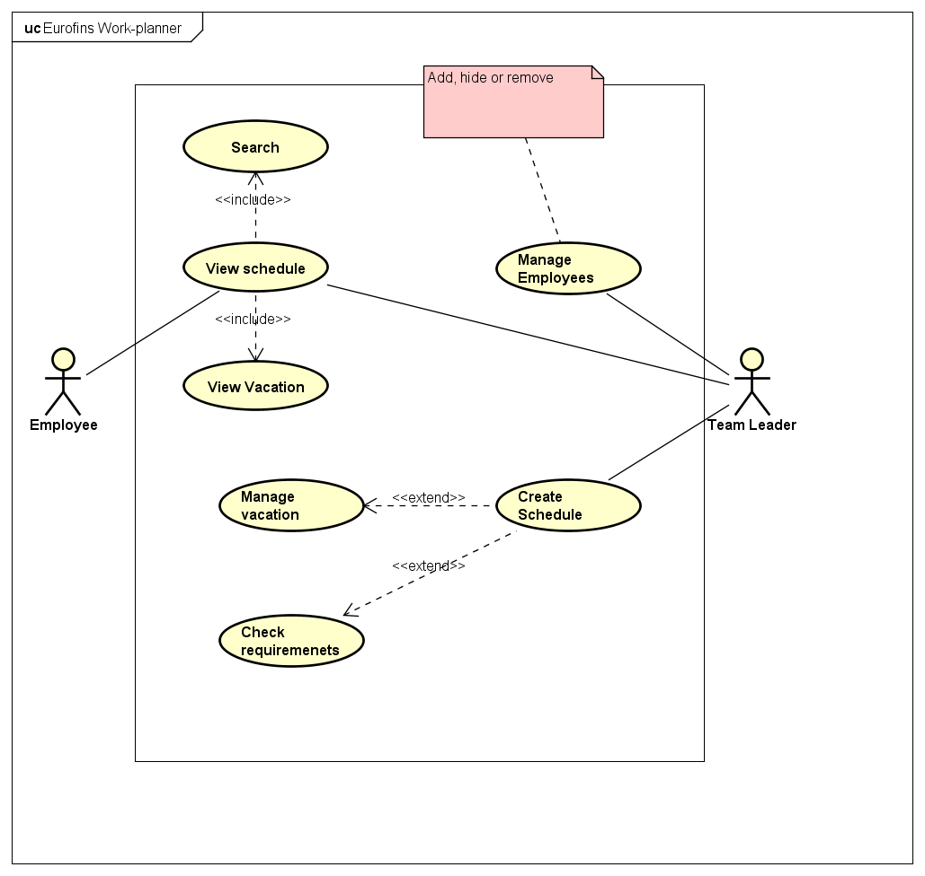

# Use case Description

|  |  |
| --- | --- |
| Use case | **View schedule** |
| Summary | A user views the current schedule |
| Actor | Team leader or Employee |
| Precondition | Schedule created |
| Postcondition | None |
| Base sequence | 1. User opens the work-planner 2. System gets current date and returns the schedule for the current week for all employees 3. User Searches for employee name 4. System returns schedule for the employee 5. User observes schedule |
| Exception sequence | No data corresponding to search parameters  1 as base sequence  The returned schedule is empty and use case ends |
| Sub use case | View vacation on schedule |
| Notes | Users can see comments |

|  |  |
| --- | --- |
| Use case | **Create schedule** |
| Summary | User creates a schedule for employee |
| Actor | Team leader |
| Precondition | Employee registered |
| Postcondition | Schedule saved for employee |
| Base sequence | 1. User opens work requirement worksheet 2. User selects a date for the test 3. User chooses the wanted test 4. Systems returns a list of available employees with training for the chosen test 5. User chooses an employee 6. User adds the test to the employees work schedule 7. System asks for approval 8. If user accepts, system saves the data to the employees work schedule |
| Exception sequence | User decides against the test to be added  Base sequence 1-7  The data is not saved to the employee |
| Sub use case | Manage Employees |
| Notes | Schedules can be changed at any time  When viewing the changed schedule, the system should show required Employees in parentheses, next to added Employees |

|  |  |
| --- | --- |
| Use case | **Manage Employees** |
| Summary | User changes data about the employee roster |
| Actor | Team leader |
| Precondition | None |
| Postcondition | Changes saved to a new list of Employees, with their credentials |
| Base sequence | 1. If ADDING an Employee, go to step 10 2. System returns a list of Employees 3. User chooses an Employee 4. If DELETE or HIDE an Employee, go to step 8   MANAGE Employees:   1. System returns a list of the Employees credentials 2. User changes the credentials 3. GO TO END   HIDE or DELETE an Employee:   1. If User wants to delete the Employee   System deletes Employee from the list of Employees   1. If User wants to hide the Employee   System sets the hidden credential of the employee   1. GO TO END   ADD Employee:   1. System returns list of empty credentials 2. User changes the values of the credentials 3. GO TO END   END:   1. System returns the changed list 2. System asks for approval 3. If approval was given, System saves the changed list |
| Exception sequence | User decides against the changes  Base sequence 1-14  The changed list is not saved |
| Sub use case | None |
| Notes | The user can cancel at any time |

# Appendix

1. The employee code is an identifier for a specific employee, based on their names initials together with a number (ex. Barbie Blondie becomes BB8)
2. Training info is information, stored with an employee’s data, that represents their training status within certain tests. The states of training are:
   * Trained
   * Needs retraining
   * Under training
3. Like training info, test preference is stored with the employee’s data, and records the employee’s preference of test (either prefer, can do, dislikes, can’t do)
4. The Employees’ code, training info, test preference, name, whether or not they are hidden etc. are grouped under ‘Credentials’.
5. The team leader is an employee that oversees the assignment of task and creation of schedule. The team leader therefore has higher privileges than regular employee’s